Parallel Trends Regression: Anti-Vaping Data

|  |  |
| --- | --- |
|  |  |
|  | Lung Hospitalizations   |  |  | | --- | --- | |  |  | |
| Pre-treat and Control Comparison | -2435.7*** |
|  | (214.2) |
| Constant | 114440.0*** |
|  | (145.3) |
| *N* | 550 |

Standard errors in parentheses

* *p* < 0.05, ** *p* < 0.01, *** *p* < 0.001

Note: This table provides regression results for the period before 2021 when the treatment was implemented. It shows that the pre-treatment group overall had 2435.7 less Lung Hospitalizations per year during this period than the control group.

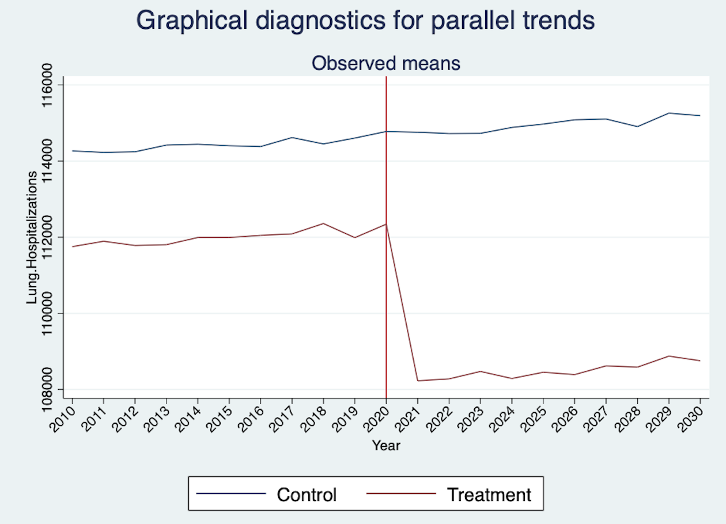

Note: This figure plots the number of lung hospitalizations pre and post adoption of anti-vaping laws in 2021, comparing states in the treatment (that enacted the anti-vaping laws) with those in the control (that did not). It shows that the parallel trends assumption is met, as the average number of lung hospitalizations in the treatment and control have similar trends in # of Lung Hospitalizations pre treatment. In is important to note, that while the trends are similar, the mean numbers of Lung Hospitalizations are lower for pre-treatment states than Control states.

Treatment Effect DiD Regression: Anti-Vaping Data

|  |  |
| --- | --- |
|  |  |
|  | Lung Hospitalizations |
| ATET |  |
| Int | -4030.5*** |
|  | (66.39) |
| Controls |  |
| 2010.Year | 0 |
|  | (.) |
| 2011.Year | 43.72 |
|  | (101.7) |
| 2012.Year | 1.140 |
|  | (105.2) |
| 2013.Year | 106.0 |
|  | (114.4) |
| 2014.Year | 205.0* |
|  | (100.7) |
| 2015.Year | 183.3 |
|  | (101.6) |
| 2016.Year | 198.0 |
|  | (114.9) |
| 2017.Year | 343.4** |
|  | (117.9) |
| 2018.Year | 378.0** |
|  | (113.1) |
| 2019.Year | 291.1** |
|  | (97.34) |
| 2020.Year | 546.8*** |
|  | (102.7) |
| 2021.Year | 497.9*** |
|  | (107.9) |
| 2022.Year | 502.0*** |
|  | (93.66) |
| 2023.Year | 594.6*** |
|  | (113.6) |
| 2024.Year | 593.9*** |
|  | (96.11) |
| 2025.Year | 716.2*** |
|  | (112.9) |
| 2026.Year | 748.9*** |
|  | (113.2) |
| 2027.Year | 865.8*** |
|  | (103.0) |
| 2028.Year | 742.0*** |
|  | (114.8) |
|  |  |
| 2029.Year | 1067.1*** |
|  | (104.9) |
| 2030.Year | 974.6*** |
|  | (116.2) |
| Constant | 113110.8*** |
|  | (72.91) |
| *N* | 1050 |

Standard errors in parentheses

* *p* < 0.05, ** *p* < 0.01, *** *p* < 0.001

Note: The table shows that the Difference-in-Differences estimator is 976.6.